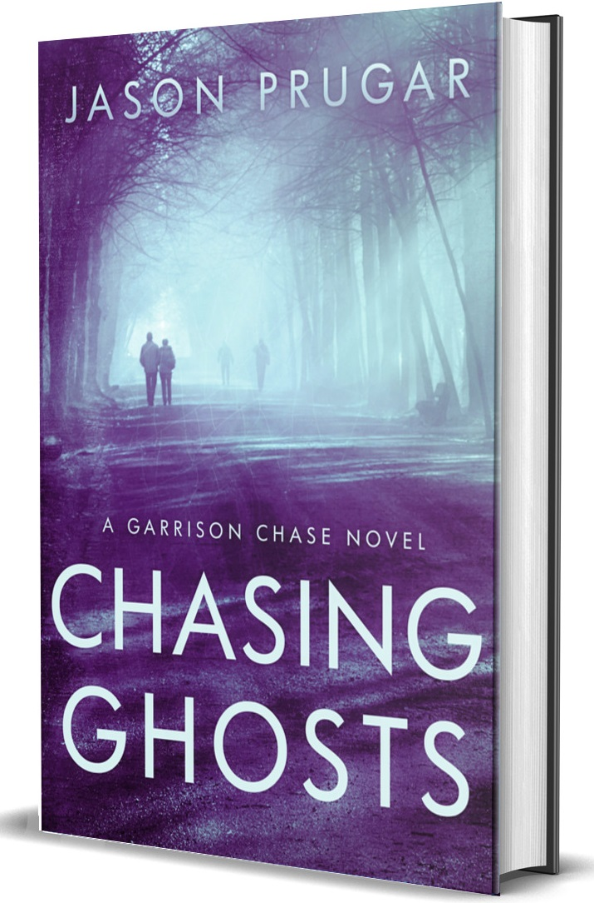


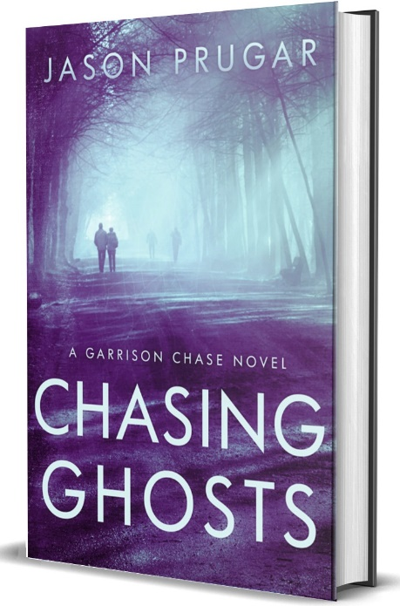
Author Bio

Book Bio

Testimonials

Target Audience

Book Excerpt

Interview Questions

Story Ideas for Reporters

Downloadable Author & Book Photos

Contact Author

Media Kit
Author: Jason Prugar
Genre: Mystery
Print ISBN: 9798349366376
Publisher: Hearthstone Media
Jason Prugar has been making up stories his entire life. That got him in trouble as a child.
Storytelling has been a passion of his since he can remember. It started with books and later, movies.
In college, a friend made a short film for an English class, and it changed his life. The following summer, he read everything his public library had on filmmaking and began crafting his own stories.
His first novel was a first step, but nowhere near ready for publication. But he never lost his love of storytelling.
The idea of a character named Garrison Chase first came to him during a rainy day on vacation in Canada in 2008. Since then, he honed the story and the life of the character, not to mention filling dozens of notebooks with ideas for additional characters and stories.
In addition to the Garrison Chase series, Jason is also the author of Tales of Gears & Grit, a steampunk shared universe of novels.
Not only that, but Jason is also prepping two short films for production in the fourth quarter of 2025.
Author Bio
Jason Prugar
Private eye Garrison Chase only wanted a quiet evening celebrating his birthday with his brother Donny and his best friend Jed. But when a stranger named Cahill barges in with plans to take over Jed's bar, Chase's night takes a dangerous turn. Determined to protect his friend's livelihood and life, Chase uncovers buried secrets that could destroy them all.

As he races against the clock to save Jed's bar from being sold at a tax sale, Chase finds himself tangled in a web of family loyalties, old debts, and hidden agendas. His investigation leads him to Jed's cousin, who is entrenched in organized crime. With powerful enemies closing in and time running out, Chase must confront the darkness lurking in his friend's past.

Amidst the chaos, Chase must navigate a world where loyalty is currency and promises are written in blood. But as the ghosts of the past resurface and debts come due, Garrison realizes that sometimes the greatest danger comes from those closest to us.

Author: Jason Prugar
Genre: Mystery
Print ISBN: 9798338255261
Publisher: Hearthstone Media

Book Bio

"Chasing Ghosts is packed with excitement and kept me turning the pages, anxiously waiting to find out what happened next.”
- Rebecca A Owens, Author of Second Chance Romance

For Chasing Ghosts
TESTIMONIALS
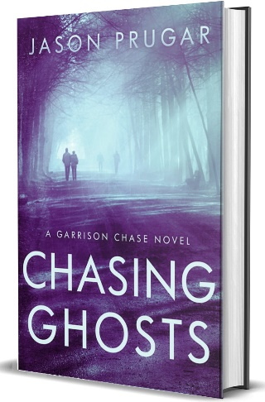
Book Excerpt
"What're you doing?" I said to Jed, pulling him back
from the rock on the edge of the mountain. "You
trying to die?"
"Lighten up, Nancy," he said, gripping the binoculars. "We're
a quarter mile up. They can’t get us from here."
Looking down, the mountain dropped off beneath my
boots in a near-vertical plunge, its face a jagged quilt of pale
rock and loose shale that looked ready to shear away at any
moment. Far below, the village clung to the hillside like it had
been flung there and forgotten—stone roofs no bigger than
thumbprints from up here. One bad step, and I’d be part of
the landscape.
"They struck the convoy outside Baghdad from almost half
a mile out," I reminded him.
"Not straight up," he said, pointing a finger in the air as he
said it.
"Don't chance it," I said. "This place is boring without you."
"Kiss ass," he said, kneeling behind the rock and out of sight.
Jed lifted the binoculars to his eyes. I winked at him. Jed and
I first bonded over our lack of preparedness for the physical
aspects of the training. Aure, I prepped as best I could, but it
was worse than I could have imagined. Jed told anyone who
listened that he did little prep, and on the first two days, he
was fine. It caught up to him on Day three, and he was back at my level. We’d been stuck together ever since. My helmet
slid down toward my right ear and I straightened it. Made me
realize how tight I gripped my rifle. We had the high ground,
sure, but the insurgents were crazy and unpredictable.

Do you have any odd writing habits?
What have you found to be most challenging about writing mysteries?
Do you identify with your main character, or did you create a character that is your opposite?
What do you enjoy most about writing mysteries?
What are some ways to get people to try my product?
What do you do when a new idea jumps out at you while you’re still working on a book?
Describe your writing process. Do you outline, plot and plan, or is your writing more organic?
At what point did you decide to be an author and what was your path to publication?

Have you ever experienced writer’s block? How did you deal with it?
What do you like to do when you’re not writing?

Interview Questions
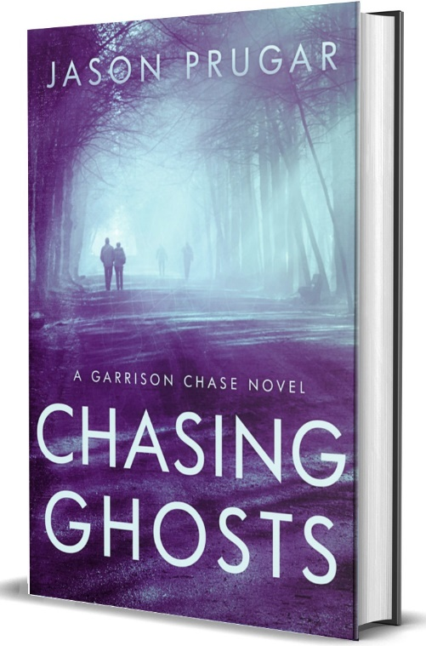
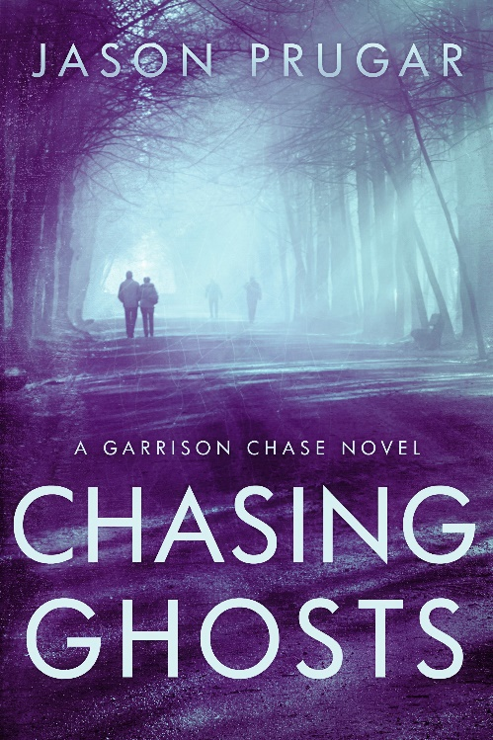



I appreciate requests for photographs for press use. Email and let us know where you post your article so we can link to it.

-Thank you.

Downloadable Photos


Connect with Jason Prugar
Email: jasonpwrites@gmail.com
Website: jasonpwrites.com
Facebook: facebook.com/jasonpwrites
Twitter: @jprug
Instagram: @jasonpwrites
TikTok: @jasonpwrites

